**LICENSE THESIS TITLE**

LICENSE THESIS

|  |  |  |
| --- | --- | --- |
|  | Graduate: | **Firstname LASTNAME** |
|  |  |  |
|  | Supervisor: | **scientific title Firstname LASTNAME** |

**2019**

|  |  |  |  |  |
| --- | --- | --- | --- | --- |
|  |  | |  | |
| DEAN, |  | | HEAD OF DEPARTMENT, | |
| **Prof. dr. eng. Liviu MICLEA** |  | **Prof. dr. eng. Rodica POTOLEA** | |

Graduate: **Firstname LASTNAME**

**LICENSE THESIS TITLE**

1. **Project proposal:** *Short description of the license thesis and initial data*
2. **Project contents:** *(enumerate the main component parts) Presentation page, advisor's evaluation, title of chapter 1, title of chapter 2, …, title of chapter n, bibliography, appendices.*
3. **Place of documentation**: *Example*: Technical University of Cluj-Napoca, Computer Science Department
4. **Consultants**:
5. **Date of issue of the proposal:** November 1, 2018
6. **Date of delivery:** July 8, 2019

|  |  |
| --- | --- |
| Graduate: | ____________________________ |
|  |  |
| Supervisor: | ____________________________ |

**Declaraţie pe proprie răspundere privind**

**autenticitatea lucrării de licenţă**

Subsemnatul(a)**________________________________________________________________________________________________________________________**, legitimat(ă) cu _______________ seria _______ nr. ___________________________   
CNP _______________________________________________, autorul lucrării ____________________________________________________________________________________________________________________________________________________________________________________________elaborată în vederea susţinerii examenului de finalizare a studiilor de licență la Facultatea de Automatică și Calculatoare, Specializarea ________________________________________ din cadrul Universităţii Tehnice din Cluj-Napoca, sesiunea _________________ a anului universitar __________, declar pe proprie răspundere, că această lucrare este rezultatul propriei activităţi intelectuale, pe baza cercetărilor mele şi pe baza informaţiilor obţinute din surse care au fost citate, în textul lucrării, şi în bibliografie.

Declar, că această lucrare nu conţine porţiuni plagiate, iar sursele bibliografice au fost folosite cu respectarea legislaţiei române şi a convenţiilor internaţionale privind drepturile de autor.

Declar, de asemenea, că această lucrare nu a mai fost prezentată în faţa unei alte comisii de examen de licenţă.

In cazul constatării ulterioare a unor declaraţii false, voi suporta sancţiunile administrative, respectiv, *anularea examenului de licenţă*.

|  |  |  |
| --- | --- | --- |
| Data  _____________________ |  | Nume, Prenume  _______________________________ |
|  |  |  |
|  |  | Semnătura |

Table of Contents

Chapter 1. Introduction 1

1.1. Traffic context 1

1.2. Connected Cars Context 1

Chapter 2. Project Objectives 2

2.1. Problem Overview 2

2.2. Project Objectives 2

2.3. Requirements 2

2.3.1. Functional Requirements 2

2.3.2. Nonfunctional Requirements 2

Chapter 3. Bibliographic Research 3

3.1. Navigation Systems 3

3.1.1. Proprietary Navigation Systems (Closed Source) 3

3.1.2. Open Source Navigation Systems 3

3.2. Maps and Data 5

3.3. Routing 5

3.3.1. Graph forms 5

3.3.2. Algorthms 5

Chapter 4. Analysis and Theoretical Foundation 6

4.1. Motivation for choosing Itinero 6

4.2. Conceptual Architecture of the System 7

4.2.1. Live Processing Module 7

4.2.2. Route Computing Module 7

4.2.3. Modules 8

4.2.4. Example of System build on the Conceptual architecture 8

4.3. TCS-3C - Design 12

4.3.1. Design 12

4.3.2. Traffic Data 14

4.3.3. Routing process 15

Chapter 5. Detailed Design and Implementation 18

5.1. Design 18

5.2. Communication 18

5.3. Live Traffic Server 18

5.4. Route Computing Server 18

5.4.1. Design 18

5.4.2. Flow 19

5.5. Traffic Simulator 20

Chapter 6. Testing and Validation 21

6.1. Hardware 21

6.2. Metrics 21

6.2.1. System metrics 21

6.2.2. Simulation metrics 21

6.3. Scenario 21

6.4. Results 22

Chapter 7. User’s manual 23

7.1. Environment 23

7.2. Dependencies 23

7.3. Route Computing Server 24

7.4. Live Traffic Server 26

7.5. Traffic Simulation 26

7.6. Distribution 28

Chapter 8. Conclusions 29

Bibliography 30

Appendix 1 (only if needed) 31

# Introduction

## Traffic context

## Connected Cars Context

# Project Objectives

## Problem Overview

## Project Objectives

There are two main objectives of this project. The first one is to design and implement a scalable and modular system that can be used in managing different aspects of the traffic in the Connected Cars Context. The system offers, in its basic form, the possibility to store the traffic status at one point and the possibility to compute routes based on that traffic status. Other functionalities can be added by connecting more modules.

The second one is developing a simulator module in order to study the effects of the route choices of the traffic participants in the Connected Cars Context. This simulated context allows following the traffic evolution under different parameters.

A list of objectives to be attained:

* Design a high-level architecture of the system in its basic form
* Decide on an open source map interpreter and route planning solution
* Setup the open source project for testing and development
* Understand all the features and limitations the open source project has
* Apply the open source solution to all the basic modules of the system
* Design a simulator module
* Decide on a set of cost parameters used for the study
* Decide on a list of metrics to study the simulated context
* Implement the simulator
* Compute and study the results of the simulations under different parameters

## Requirements

### Functional Requirements

Based on the presented objectives, the functional requirements resemble the features of the project. Each requirement is shortly described, but more details about the design and implementation of these features can be found in chapters 4 and 5.

* Component able to generate routes based on different factors
* Component able to hold the status of the traffic and update it when necessary
* Design that allows distribution of the system over multiple machines
* Component able to simulate the traffic context
* Simulator should be able to display statistics over the length of the entire simulation
* Simulator should output detailed statistics at the end of the simulation

### Nonfunctional Requirements

# Bibliographic Research

## Navigation Systems

A navigation system is an electronic system that facilitates the navigation. They are composed of both software and hardware. Navigation systems can be offline, online or a combination of both.

Offline navigation systems assume that all the data is on board of the using party and doesn’t need any kind of aid from remote components.

Online systems have components that are located in fixed points and the using party communicates with it in order to receive the navigation information needed.

The hybrid systems can have the map information stored locally but still request routes from a remote component with higher computational power.

### Proprietary Navigation Systems (Closed Source)

A proprietary software is a kind of software that doesn’t allow anybody but the developing team see or modify the source code. This kind of software is usually developed by companies that sell that product or offer it for free but generate profit out of it.

The most used proprietary navigation systems are the ones that are offline. These come integrated with the car and are provided by the car manufacturer or can be purchased separately as GPS devices from separate manufacturers. These systems are able to provide routes, direction, traffic information (e.g. speed limits) even in the absence of an open internet connection.

On the other hand, with the development of the mobile devices, the online navigation systems got to increase their popularity and reach. By benefiting from internet connection these systems are able to offer the user a wider range of maps. They can also provide way more information on what concerns the current traffic status in certain areas, reviews and even street-level photos. The most relevant examples of online navigation apps are Google Maps and Waze. The fact online factor allows these apps to use user location in order to map the traffic and it allows them to use user data in order to show traffic information like traffic jams, police locations and many others. They offer the possibility to build a route in different ways: shortest distance, shortest time, least consumption, etc. Even if they have all these features, they still take into consideration only the user’s choice when it comes to routing. They do not try to improve the entire context, but only the requesting users’ route, even if they have one of the largest Connected Context when it comes to maps and navigation.

Considering the above mentioned, we are not able to use these systems directly in order to study and improve the Connected Cars Context.

### Open Source Navigation Systems

An open source software is a type of software that are licensed by their developers in such a way that it grants users access to the code and it allows them to study, change and distribute the software, no matter the purpose. Most of these softwares are developed in a collaborative manner, many individual developers helping the process of designing, writing and testing the product.

These kinds of projects are the best choice for somebody that wants to try new routing techniques or even trying a new approach in the context of navigation systems. Writing a navigation software from scratch is a huge project and usually not worth it as the number of open source projects is big enough that it is almost sure that one can find a good starting point for their approach. Most of these projects are designed in such a way that they can be built over.

For this project, from the research of the open source community projects, two of them stood out.

* *OsmAnd*

OsmAnd, presented in [1], is an open source software that runs on Android and iOS devices and is able to process OpenStreetMap data fully offline. OsmAnd has multiple navigation features like turn-by-turn voice guidance, traffic warnings (stop signs, pedestrian crosswalks, speed limits, etc.) and it has features for pedestrians and bicycle riders as well.

The software was developed by a team of over 500 members and the entire source code is available on GitHub [2] under a license that allows any developer to modify and distribute the project, as long as they do it under the same type of license.

The international community that takes part in the development of this product offered a huge collection of functionalities and elements on maps from over 40 countries, but it also brought a large set of undocumented features. The different coding styles approached by the developers affect the clarity of the projects code and makes it difficult for someone to build over it.

* *Itinero*

Itinero, presented in [3], is an open source project built for route planning that was originally designed for logistical optimization. Just as OsmAnd [2], it processes OpenStreetMap data fully offline and it offers step by step instructions in routing. It can provide routes for cars, bicycles, pedestrians, mixed or custom profiles. On top of that, it can be used both as a library and a routing server for other projects, making it perfect for the development of other traffic related projects.

The Itinero project was developed by Ben Abelshausen [4], who is a Belgian optimization algorithms and routing expert that builds route planning and mobility solutions based on OpenStreetMap. He is also the owner of Anyways BVBA and Itinero as a company.

## Maps and Data

## Routing

### Graph forms

### Algorithms

# Analysis and Theoretical Foundation

## Motivation for choosing Itinero

There are multiple reasons for which Itinero was chosen for developing this diploma project.

First of all, Itinero offers the possibility to be used as a library in any .NET project. That means the route computing is extremely customizable and can be used even for our very specific route computing criteria. It also means that the data structures used along the distributed components of this project are exactly the same, using as little effort to communicate as possible. The fact that Itinero is more of a tool than an application itself, allows the further development of a distributed system that uses it in all its components to be very easily extended.

Second of all, the way Itinero manipulates the map information is very well implemented, making it lightweight memory wise and fast even in the scenario of a distributed system, like in the case of this diploma project.  Every data structure offers custom serialization and deserialization, which makes Itinero really fast when it comes to loading and transferring data.

Moreover, the fact that Itinero was developed by a single person (with confirmed design, algorithmic and development skills) ensures that the project is uniformly written. The code flows are consistent and well implemented and coding style is the same in the entire project, so the entire software is comfortable to study and understand, even if it it really heavy when it comes to the content of the code.

To complete the above stated argument, Itinero comes with a good documentation, both in the wiki page and in code comments. Because of this, understanding it and finding answers to almost any technical questions regarding Itinero is not as difficult as it might be in the case of other projects. Besides that, as this diploma project required some really specific tools from Itinero’s kit, whenever something was not clear enough, Ben, the developer of Itinero, was kind enough to provide the needed help.

Last but not least, the technical stack used in the development of Itinero, .NET framework written in C#, completed the list of arguments for taking this decision.

## Conceptual Architecture of the System

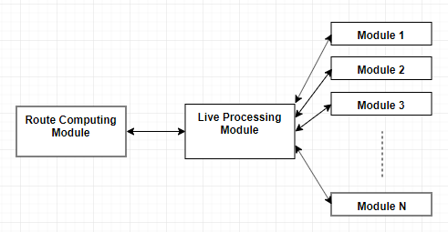

Figure . Conceptual Architecture of the TCS-3C

As a distributed system, the currently described project is built using modules. The main components are the Live Processing Module and the Route Computing Module. All other possible modules would communicate directly to the Live Processing Module.

### Live Processing Module

The Live Processing Module is the core of this system. It is the module that supports or controls the actions of every other component in the system. It also holds the current state of the traffic.

This module has 2 types of input: route requests and notifications relating traffic. These inputs are received from Active Modules (4.3.2.). This module can also request traffic information from Passive Modules, in order to keep the traffic status, it holds up to date.

When a route request is received, the Live Processing Module requests the latest traffic data from the available Passive Modules (4.3.2.), in order to ensure the reliability of the currently held traffic data. Then it makes a request to the Route Computing Server for a route and after it receives the route, it sends it to the requesting module.

### Route Computing Module

The Route Computing Module is the component of the system that takes care exclusively of computing routes, considering only the c2c infrastructure. It receives as input a route request and it returns the computed route based on the current status of the traffic. Whenever a route request is received, this module loads the traffic data that was updated by the Live Processing module.

### Modules

* Active Modules

Active Modules are the type of modules that take direct actions in or regarding the traffic context. These modules are usually Client applications for Traffic Researchers, Traffic Participants or Traffic Managers. These modules are the ones that provide the input to the Live Processing Module and they process the responses received.

* Passive Modules

Passive Modules are the type of modules that hold a traffic status of their own based on their own input and receive requests from the Live Processing Module. They provided their current status to the Live Processing Server and it will take this information into consideration when updating the general traffic status.

### Example of System build on the Conceptual architecture

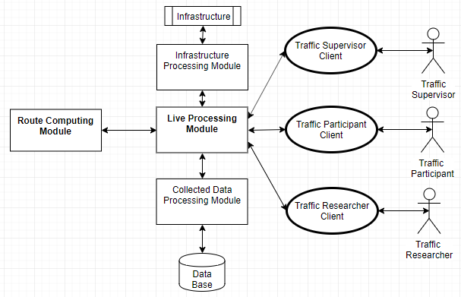

Figure 4.2 Example of architecture based on the conceptual architecture

Figure 4.2. describes a system built on the conceptual architecture presented in the previous pages (4.3). The system above respects the structure proposed and has the main components and 5 other modules (3 active modules and 2 passive modules).

**- Live Processing Module**

As described at point 4.2.1., the Live Processing Module is the core module of the system. It holds the current traffic status, updates it constantly and communicates with all the other modules of the system.

The Live Processing Module has 2 type of inputs. The first type of input is  traffic status updates, received from the Traffic Participant Client Active Module, Traffic Manager Client Active and, on request, from the 2 Passive Modules of the system. The Live Processing Module uses these updates to keep the traffic status up to date.

The second type of input received are requests. The Traffic Participant Client can request  routes and the Live Processing Server forwards the request to the Route Computing Module and after it receives the response it outputs that response to the Traffic Participant client. On the other Hand the Traffic Researcher Client can request for statistics on different topics of the traffic status. When that input is received, the Live Processing Server computes and outputs the requested statistics.

* **Route Computing Module**

As described at point 4.2.2., the Route Computing Module has the purpose to answer route requests with a route, based on the current status of the traffic, if it is possible to build one, or with an error message if the route cannot be computed.

**- Active Modules**

* **Traffic Participant Client**

The Traffic Participant Client Module is the client application that can be used by the Traffic Participant stakeholder. This module aids the Traffic Participant in the process of requesting a route.

After a route is received the module presents the Traffic Participant with the route, guides them and sends constant location updates to the Live Processing Module, so the traffic status can be updated.

* **Traffic Manager Client**

The Traffic Manager Client Module is the client application that can be used by the Traffic Manager stakeholder. It offers the Traffic Manager the possibility to bring changes to the traffic context, like blocking a certain area of the city for various events.

* **Traffic Researcher Client**

The Traffic Researcher Client Module is the client application that can be used by the Traffic Researcher stakeholder. It offers the Traffic Researcher the possibility to request the Live Processing Module for various statistics on what concerns the traffic.

**- Passive Modules**

* **Collected Data Processing Module**

The Collected Data Processing Module is the passive module that is responsible with storing the traffic data received or computed by the Live Traffic Server. This module has Direct connection to a database in which it stores the collected data, and from which it retrieves and analyses traffic data.  It can provide the Live Traffic Module, on demand, with information regarding the overall usual status of the traffic at certain times/dates in the past.

* **Infrastructure Processing Module**

The Infrastructure Processing Module is the passive module that is responsible for communicating with the infrastructure systems, like live traffic cameras or proximity car counters, and build a status traffic model based on the information received from these systems. It is able to answer the Live Traffic Modules requests with the live status traffic computed using the traffic data from the infrastructure.

* A route request Use-Case, from the perspective of the Live Traffic Module, is presented in the following flow diagram.

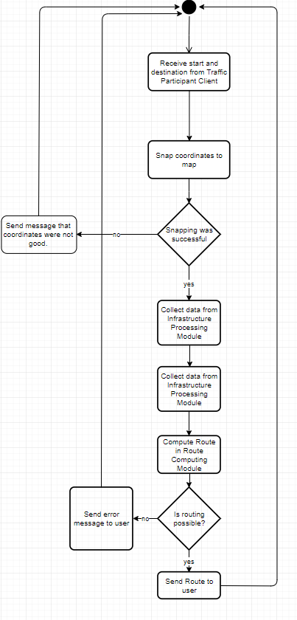

Figure 4.3 Flow diagram of route request Use-Case

## TCS-3C - Design

### Design

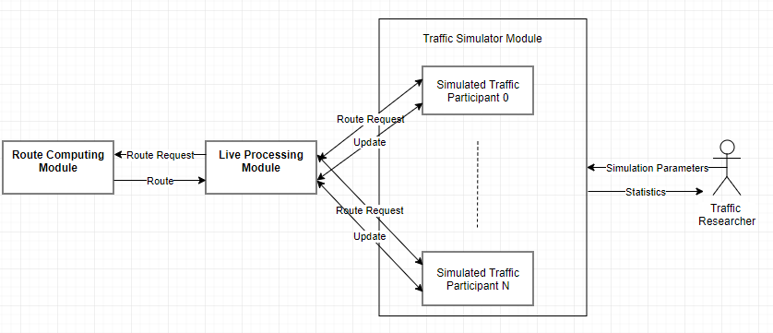

Figure 4.4 Design of TCS-3C

Figure 4.4. describes the architecture of TCS-3C. It respects the conceptual diagram described earlier (4.2.). It has the main modules, the Live Traffic Module and the Route Computing Module, and one active module, the Traffic Simulator Module.

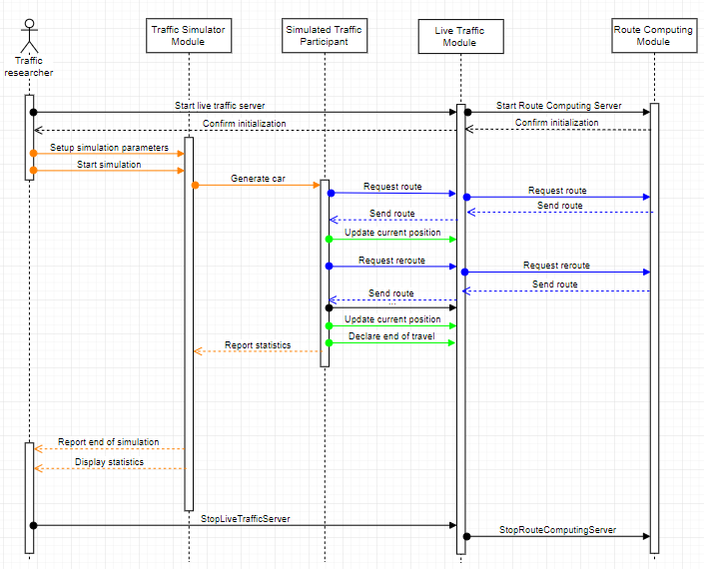

Figure 4.5 Sequence Diagram of a TCS-3C

Figure 4.5. describes a simulation in terms of inter-module communication in the TCS-3C system.

* **Live Processing Module**

As it was previously described, The Live Processing Module is the main module of the system. It has the purpose of connecting all other modules in the system. In this case, the Live Processing Module has a direct connection to the Route Computing Module and to the Traffic Simulator Module.

This module manages the request for routes received from the Simulator Module. Whenever a route request is received, the Live Traffic Module forwards it to the Route Computing Module, together with the current status of the traffic. It then expects a route and forwards it to the simulated traffic participant. These actions can be found colored blue in Fig 4.4.

It maintains the current status of the traffic by updating it periodically when location updates are received from traffic participants simulated by the Traffic simulator. These actions can be seen in color Green in figure 4.4.

* **Route Computing Module**

As described at point 4.2.2., the Route Computing Module has the purpose to answer route requests with a route, based on the current status of the traffic, if it is possible to build one, or with an error message if the route cannot be computed.

* **Traffic Simulator Module**

This module is the interface of the Traffic Researcher in TCS-3C. Its purpose is to generate a traffic context based on a set of parameters and create statistics on the effects of Traffic Participants choices, made in traffic. These effects can be studied by varying a threshold (0%-100%) of people taking the best route over the shortest one and comparing the total times of the simulated contexts.

It simulates traffic participants, giving each one of them a type of behavior, a starting location and an ending location. Each one of these traffic participants requests a route and starts following it, according to their behavior, updating their position and requesting reroutes when necessary.

During the simulation process, the module gathers statistics from the simulated traffic participants and displays them to the user at different points in the simulation and at the end of it.

These actions can be seen in Fig 4.4. colored orange.

### Traffic Data

Previous points stated that the Live Traffic Module holds the traffic status in order to be used when the routing is done. This traffic status is a combination of the already existent map information and some extra properties. Besides the basic data related to the maps, presented at 3.x(TAG), in order to hold the traffic related data, each edge has two additional characteristics:

* car-count: The number of cars that can be found on that edge at the time of the query
* custom-speed: A speed that was computed for that edge

An example can be found in the following image.

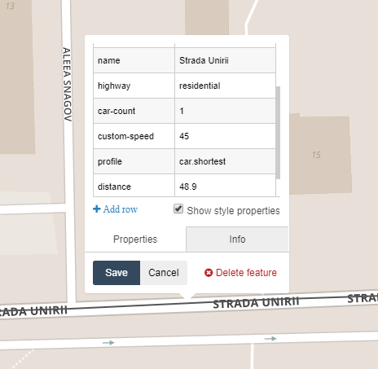

Figure 4.6 Screenshot of partial information recorded about an edge on the map

Normally, the speed associated with an edge is hardcoded and is equal to the speed limit legally imposed for that edge. In the case of TCS-3C, besides the legal speed limit, the number of cars present at one time on that edge and their average length influences the speed that can be reached on that edge. The function that determines the new speed can be easily changed in the system and the current form of this function is the following:

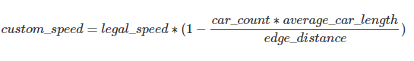

For example, in the picture above the legal speed limit is 50 km/h in that area, the number of cars on that edge is 1, the average car length is 4 meters and the edge distance is 48.9 meters. That gives us, using the formula above,  a custom speed of 45.7 km/h, which is rounded to 45.

This function dictates the new speed for every edge that will be used for routing.

### Routing process

The routing process takes place in the Route Computing Module.

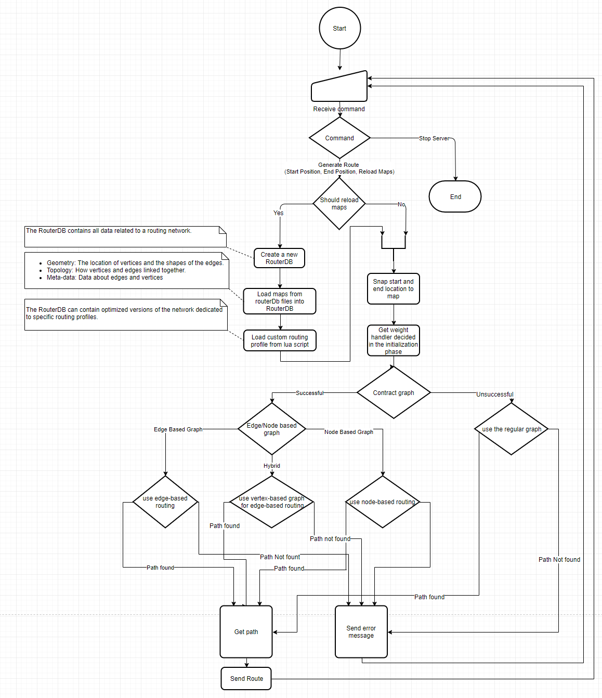

Figure 4.7 Flow Chart of route computing process

The first steps of the process include deciding whether the traffic status should be reloaded or not. If there were enough changes in the traffic context, the routerDb is reloaded.

The second part of the routing process is validating the start and end locations. It consists of checks whether the two pairs of coordinates are included in the map that is currently concerned. If the points are inside the map, the next step is checking if these points can be snapped to the road network in the map or if they are too far.

After the input data is validated, the next step is trying to contract the graph. This step minimizes the size of the graph so less effort is required in the route computing process. This process removes from the routerDb the information that is not used for the current routing profile. For example, if the current routing is only done for cars, all information about pedestrians and bicycles can be removed from the routerDb, as it won’t be used. This step also removes the nodes that have under three neighbors. The contraction also includes transforming the basic graph into an edge-based graph, if possible. This action would make the edges the main point of interest in the routerDb and the nodes would become edges. This would allow speed up in the routing process and would make it easier to model turn restrictions.

The last part of the process is the actual routing. Route computing is done using a custom bidirectional Djkistra’s algorithm, for each form of the graph. This algorithm There are 2 types of routing in TCS-3C:

* shortest - a bidirectional Djkistra’s algorithm adaptation that takes as weights the length of the edges and the legal speed limit. This type of routing is used by the greedy Traffic Participants.
* best - a bidirectional Djkistra’s algorithm adaptation that takes as weights the length of the edges and the custom speed computed for each edge (4.3.2)

# Detailed Design and Implementation

## Design

## Communication

## Live Traffic Server

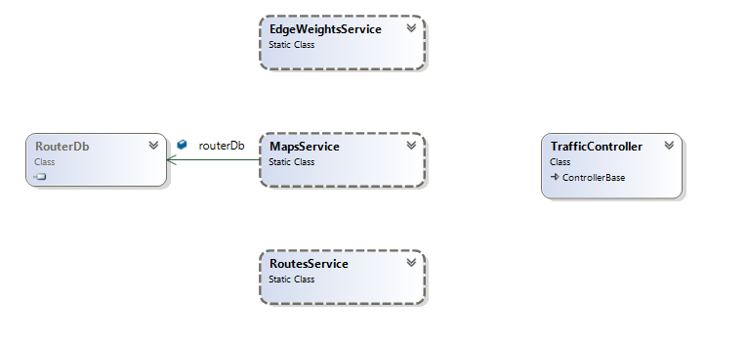

Figure 5.1 High level class diagram of Live Traffic Server (from Visual Studio)

## Route Computing Server

### Design

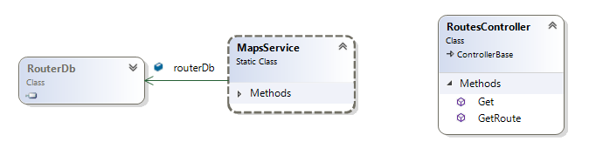

Figure 5.2 High level class diagram of Route Computing Server (from Visual Studio)

### Flow

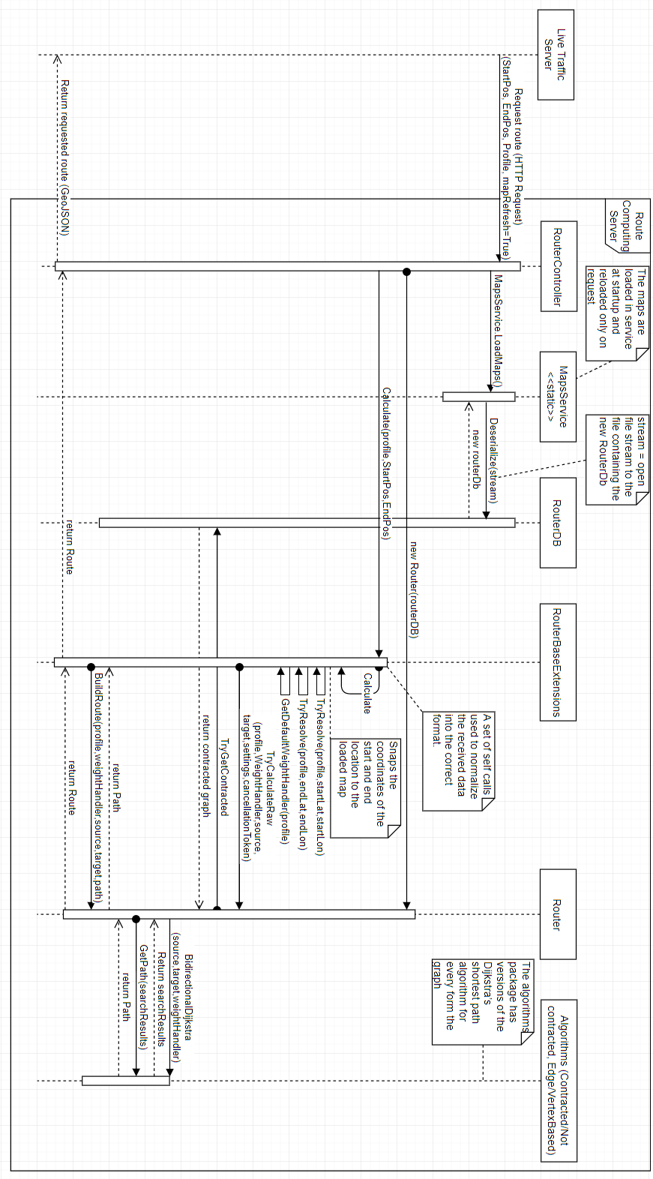

Figure 5.3 Flow diagram of a route request with map refresh

## Traffic Simulator

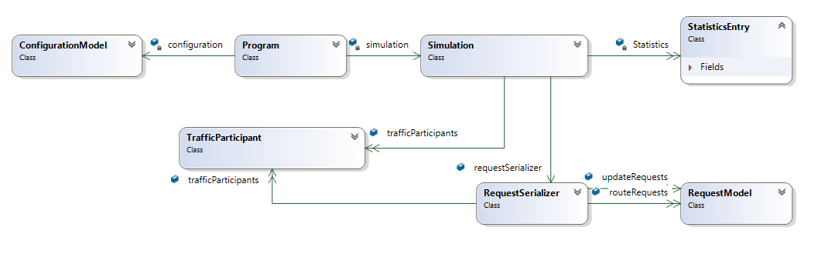

Figure 5.4 High level class diagram of Traffic Simulator (from Visual Studio)

# Testing and Validation

## Hardware

Testing was done using 3 different setups:

1. Intel Core i5-4460 3.20 GHz, 16 GB RAM, 100 GB free SSD storage
2. Intel Core i7-4720 2.60 GHz, 16 GB RAM, 60 GB free SSD storage
3. Intel Core i5-6700 2.60 GHz, 16 GB RAM, 100 GB free SSD storage

## Metrics

In order to study the efficiency of the presented project, metrics should be defined for both the system itself and the effects of the system in the connected cars context, computed using the implemented Traffic Simulator (4.3.1.).

### System metrics

The system metrics are the characteristics of the system, measuring the way this works. These metrics would show the capabilities of the system in any module configuration. They focus especially on the Live Traffic Server and on the Route Computing Server.

* Live Traffic Server route request response time: The time it takes for the Live Traffic Server to respond to a request for a route.
* Route Computing Server route request response time: The time it takes for the Route Computing Server to receive a route request, compute that route and respond to the request.
* Live Traffic Server Update request response time: The time it takes for the Live Traffic Server to respond to an Update Request.

### Simulation metrics

The Simulation metrics are the characteristics of the results obtained by running different scenarios in the Traffic Simulator. These metrics are used to analyse and compare different approaches of implementation or different traffic scenarios.

* Simulation length: the amount of time it took for the Traffic Simulator to finish the job
* Total time: the sum of the durations of all routes simulated
* Average route time: the average duration of the routes simulated
* Average speed: the average speed of the Traffic Participants simulated
* Average touched features: the average number of edge sets touched by the Traffic participants while following the simulated routes
* Average route request wait time: the average time the simulated traffic participants had to wait for one route request
* Average update request wait time: the average time the simulated traffic participants had to wait for one update request

## Scenario

## Results

# User’s manual

This chapter comprises the installation of all the components of the developed system as well as methods to test each one of these components. Furthermore, all the development and testing were done on only one machine at a time, with some supplementary steps the system can be easily distributed. The choice of testing only on one machine at a time was made so the speed of the simulation was as big as possible.

## Environment

For running of the current version of the system the user needs the Visual Studio IDE. The development was done using Microsoft Visual Studio Express 2017. Using a different version of Visual Studio might create issues. .NET Core 2.0 was used in the development of the Live Traffic Server and Route Computing server so the user must make sure the .NET Core SDK is installed, by checking the “.NET Core cross-platform development” in the installation/modifying wizard of Visual Studio.

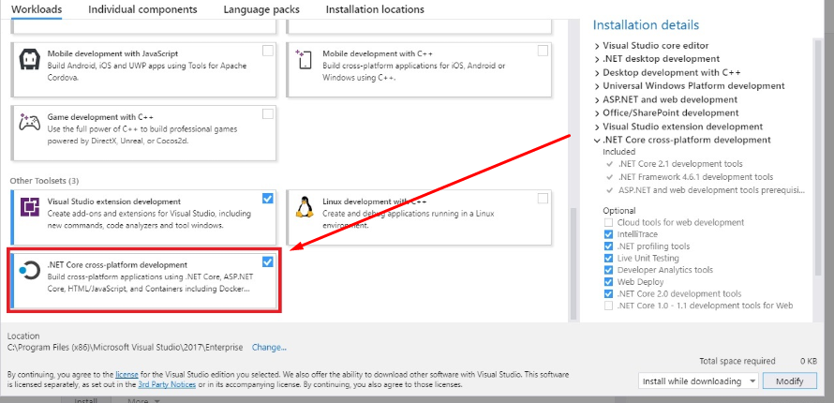

Figure 7.1 Visual Studio installation wizzard

## Dependencies

Each module of the system uses a few external elements. These elements have to be present in order for the system to work. In the case of a distribution of the system over multiple machines the following steps must be done for each machine.

* Download the project from [5]
* Create a folder destinated for map related files
* Create a folder destinated for the results of the simulation
* Download the map of the country of focus from [6]
* Reduce the map to the specific area of focus using instructions from [7] (the smaller the area, the faster the system)
* Add the .pbf file of the area to the folder created at step 1.
* Make sure that the CommonVars.cs and SharedAssemblyVersion.cs files are in the same folder with the components of the system on the machine.

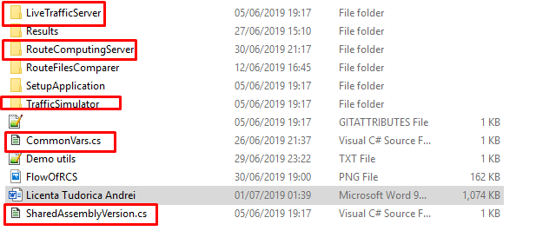

Figure 7.2 Screenshot of the folder containing components and common files

* Open the CommonVars.cs file
* Change the value of “PathToCommonFolder” to be the path of the folder you created for the maps
* Change the value of “PathToResultsFolder” to be the path of the folder you created for the results
* Add the custom-car.lua file, that can be found in the root folder of the system, in the folder destinated for maps
* Change the “PbfFileName” value to be equal to the name of the final map to be used
* Change the “RouterDbFileName” to match with the target area
* Run the SetupApplication found in the same folder with all the components

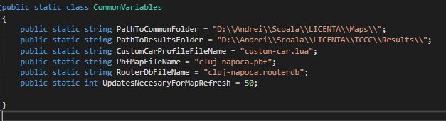

Figure 7.3 Screenshot of CommonVars.cs in current version

## Route Computing Server

The Route Computing Server code can be found in the “RouteComputingServer” folder of the downloaded system. After all the steps at 7.2. are completed, run the .sln file and compile the project. This should open a page saying the Route Computing Server is running and waiting for commands. Testing can be done by building a link containing 2 locations on the chosen map.

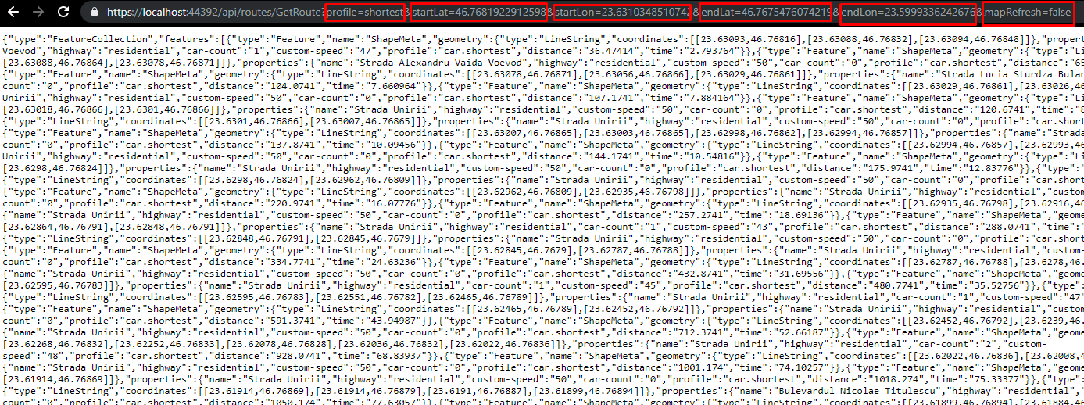

Figure 7.4 Screenshot of test run for the Route Computing Server

Figure 7.4. presents an example of usage for the following link:

https://localhost:44392/api/routes/GetRoute?profile=shortest&startLat=46.7681922912598&startLon=23.6310348510742&endLat=46.7675476074219&endLon=23.5999336242676&mapRefresh=false. The response of the Route Computing Server is a GeoJson string containing a route. By pasting this into [8] the visualization of this route is obtained.

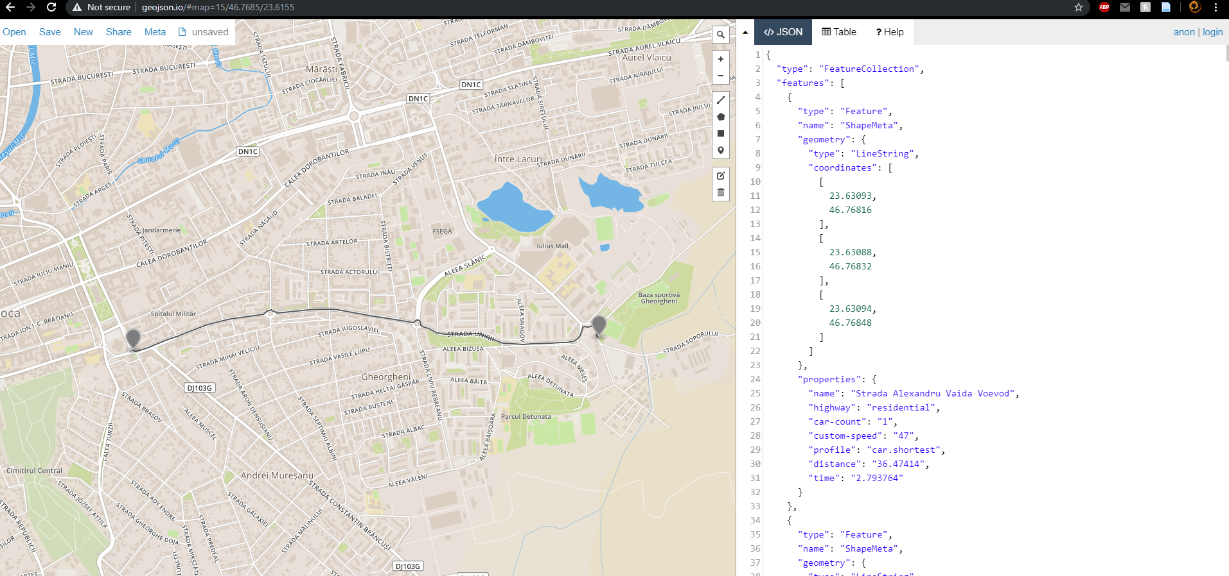

Figure 7.5 Screenshot of the visualization of the response received by the command in Figure 7.4.

For best performance the Route Computing server should be done in Release mode. This can be done by selecting „Release” in the run mode dropdown menu and pressing CTRL+F5.

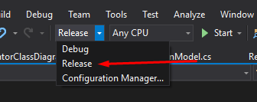

Figure 7.6 screenshot of run mode dropdown menu in Visula Studio

## Live Traffic Server

The Live Traffic Server code can be found in the “LiveTrafficServer” folder of the downloaded system. After all the steps at 7.2. are completed, open the .sln file. Open the Constants.cs file in Visual Studio and modify the value of “RouteComputingServerURL” so that it matches the URL where the Route Computing Server. In a local environment this is "https://localhost:44392/".

When the project is run a page saying “Live Traffic Server is Running. Waiting for commands.” should open.

The server initializes the maps by itself at start up. The functionality can be tested by building a link containing 2 locations on the chosen map just like the one for the Route Computing server.

Example: https://localhost:44351/api/traffic/GetRoute?profile=shortest&startLat=46.7681922912598&startLon=23.6310348510742&endLat=46.7675476074219&endLon=23.5999336242676

The visualization of the answer follows the same steps ast the ones for the Route Computing Server.

For best performance the Route Computing server should be done in Release mode. This can be done by selecting „Release” in the run mode dropdown menu (Figure 7.6) and pressing CTRL+F5.

## Traffic Simulation

The Traffic Simulator code can be found in the “TrafficSimulator” folder. After all the steps at 7.2. are completed, open the .sln file. Open the SimulationParameters.json file in Visual Studio and modify the value of the “LiveTrafficServerUri” such that it matches the URL where the running Live Traffic Server can be found. In a local environment that link should be "https://localhost:44351". Modify the other simulation parameters so they match the desired simulation.

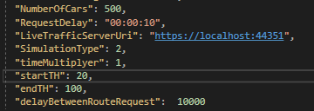

Figure 7.7 Example of simulations parameters.

Run the simulator in release mode to get live statistics about the simulation.

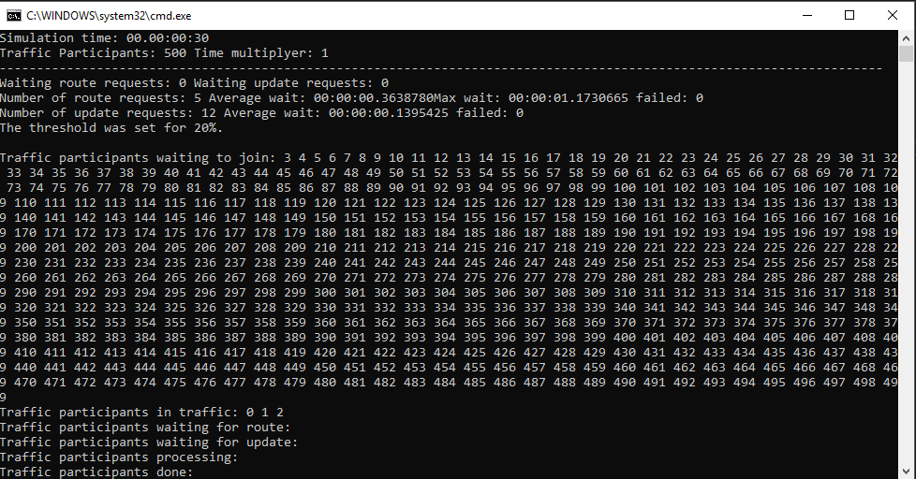

Figure 7.8 Screenshot of simulator run in Release mode

Run the simulator in Debug mode to follow the Simulation step by step. This might be really hard to followas the updates move quite fast.

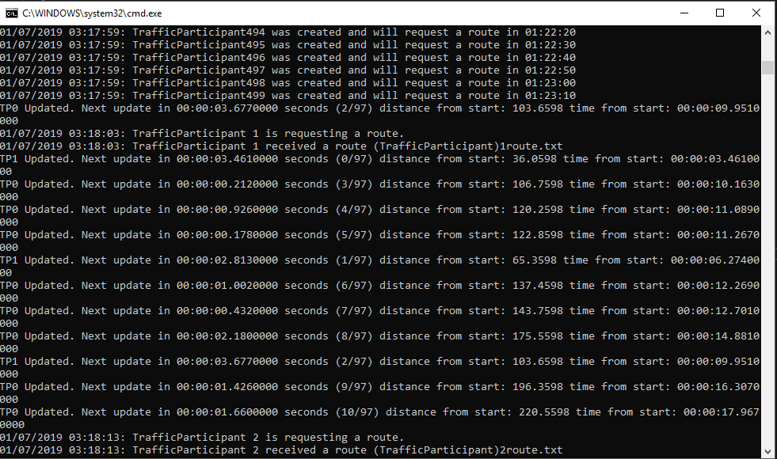

Figure 7.9 screenshot of simulator run in Debug mode

The results of the simulation can be found on the console during the simulation and at the end of it. Also, at the end of the simulation, in the Results folder that was created at 7.2, the simulator creates files for the entire simulation statistics and for each traffic participant.

For best performance the Simulator should be done in Release mode.

## Distribution

In order for the system to be distributed a couple of changes should be made.

First of all, the live traffic server’s code should be modified so it writes the routerDb in the route request to the Route Computing Server, not in a local file. Also, the Route Computings code shoud be modified such that the Route Computing receives a routerDb in the route request body and deserializes it in the local RouterDb structure.

The second part would be changing the IIS settings and making the server discoverable, just like in [9]. This can be done for both the Live Traffic Server and for the Route Computing Server.

# Conclusions

About. 5% of the whole.

In this chapter you present:

* A summary of your contributions/achievements,
* A critical analysis of the results achieved,
* A description of the possibilities of improvements/further development.

# Bibliography

|  |  |
| --- | --- |
| [1] | “OsmAnd Web page,” [Online]. Available: https://osmand.net/. |
| [2] | “OsmAnd Repository,” [Online]. Available: https://github.com/osmandapp/Osmand. |
| [3] | “Itinero Web Page,” [Online]. Available: https://www.itinero.tech/. |
| [4] | B. Abelshausen, “Linked In page,” Itinero, [Online]. Available: https://www.linkedin.com/in/benabelshausen/?originalSubdomain=be. |
| [5] | A. Tudorica, “Licence Thesis Repo,” [Online]. Available: https://github.com/andreitudorica/UTCN_LICENTA. |
| [6] | “OpenStreetMap Data Extracts,” [Online]. Available: https://download.geofabrik.de/. |
| [7] | “OsmConvert Wiki,” [Online]. Available: https://wiki.openstreetmap.org/wiki/Osmconvert. |
| [8] | “GeoJson,” [Online]. Available: http://geojson.io. |
| [9] | “Remote Access to Local ASP.NET Core Applications,” [Online]. Available: https://blog.kloud.com.au/2017/02/27/remote-access-to-local-aspnet-core-apps-from-mobile-devices/. |

# Appendix 1 (only if needed)

…

Relevant code sections

…

Other relevant info (proofs etc.)

…

Published papers (if any)

etc.